Exp no: 2 Keerthika.K
241901046

TCP Client–Server using Socket Programming in Python

AIM:
To write a Python program to implement communication between a TCP client and a TCP server using socket programming.

INTRODUCTION:
Socket programming is a way of connecting two nodes on a network to communicate with each other.
A socket acts as an endpoint for sending and receiving data across a network.
In TCP (Transmission Control Protocol), a connection-oriented communication is established where data is delivered reliably and in the correct order.
A TCP server waits for a connection request from a client. Once connected, both can send and receive messages until the connection is closed.

ALGORITHM (Server Side):
1. Start the program.
2. Import the socket module.
3. Create a socket object using socket. socket() .
4. Bind the socket to a specific IP address and port using bind ((host, port)) .
5. Listen for incoming connections using listen() .
6. Accept the connection from a client using accept() .
7. Receive data from the client using recv() .
8. Send a response back to the client using send() .
9. Close the connection after communication ends.
10. Stop the program.
ALGORITHM (Client Side):
1. Start the program.
2. Import the socket module.
3. Create a socket object using socket. socket() .
4. Connect to the server using connect((host, port)) .
5. Send data to the server using send() .
6. Receive the server's response using recv() .
7. Display the received message.
8. Close the connection.
9. Stop the program.

Server (code):
import socket
sockfd=socket.socket(socket.AF_INET, socket.SOCK_STREAM)
print('Socket Created')
sockfd.bind(('localhost',55555))
sockfd.listen(3)
print('Waiting for connections')
while True:
clientfd,addr=sockfd.accept()
receivedMsg=clientfd.recv(1024).decode()
print("Connected with ",addr)
print("Message Received from Client: ",receivedMsg)
clientfd.send(bytes(receivedMsg,'utf-8'))
print("Message reply sent to Client!")
print("Do you want to continue(type y or n):")
choice=input()
if choice=='n':
break

Client (code):
import socket
clientfd=socket.socket(socket.AF_INET, socket.SOCK_STREAM)
clientfd.connect(('localhost',55555))
name=input("Enter your message:")
clientfd.send(bytes(name,'utf-8'))
print("Message Received from Server: ",clientfd.recv(1024).decode())

Server (status):
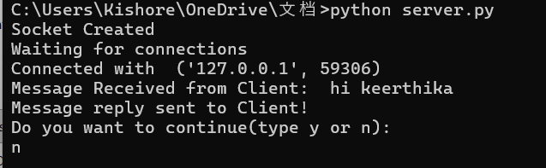

Client(status):
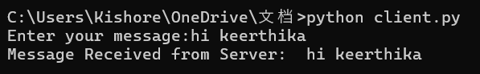

RESULT:
The Python program for TCP client-server communication was executed successfully…

